**PIZZA PRICE PREDICTION**

A Project Report in partial fulfillment of the degree

# Bachelor of Technology

in

# Computer Science&Engineering

## By

**2103A51052** K.GREESHMA

**2103A51132** V.VARSHA

**2103A51044** D.HASINI

**Under the Guidance of**

# D. Ramesh

# Assistant Professor, Department of CSE.

**Submitted to**



# DEPARTMENT OF COMPUTER SCIENCE &ENGINEERING

## SR UNIVERSITY,ANANTHASAGAR,WARANGAL





**DEPARTMENT OF COMPUTER SCIENCE & ENGINEERING**

**CERTIFICATE**

This is to certify that the Project Report entitled “Pizza Price Prediction” is are cord of Bonafide work carried out by K. Greeshma , V. Varsha , D. Hasini bearing RollNo (s) 2203A51052,2203A51132,2203A51044 during the academic year 2024-2025 in partial fulfillment of the award of the degree of Bachelor Of Technology in Computer Science & Engineering by the SR UNIVERSITY , WARANGAL.

# Supervisor Head of the Department

Mr. D. Ramesh Dr. M. Shashikala

Asst. Professor, Assoc. Prof .& HOD (CSE)

SR University SR University

**ACKNOWLEDGEMENT**

We express our thanks to course coordinator Mr. D. Ramesh, Asst. prof. for guiding us from the beginning through the end of the course project. We express our gratitude to head of the department CS&AI, Dr. M. Shashikala, Associate Professor for encouragement, support and insightful suggestions. We truly value their consistent feedback on our progress, which was always constructive and encouraging and ultimately drove us to the right direction.

We wish to take this opportunity to express our sincere gratitude and deep sense of respect to our beloved Dean, School of Computer Science and Artificial Intelligence, Dr C. V. Guru Rao, for his continuous support and guidance to complete this project in the institute.

Finally, we express our thank to all teaching and non-teaching staff of the department for their

suggestions and timely support.

# ABSTRACT

Pizza price prediction has gained significant attention due to its relevance in the food industry and consumer behavior analysis. In this study, we present a data-driven approach to forecast pizza prices based on various factors such as ingredient costs, location, seasonal trends, and consumer preferences. Leveraging machine learning algorithms and regression techniques, we analyze a comprehensive dataset comprising historical pizza prices and relevant features.

Our methodology involves data preprocessing, feature engineering, and model selection to develop accurate price prediction models. We explore the significance of different features in influencing pizza prices and assess the performance of various machine learning models, including linear regression, decision trees, and ensemble methods.

Furthermore, we investigate the impact of external factors such as economic indicators, market trends, and competitor pricing strategies on pizza prices. Through rigorous evaluation and cross-validation techniques, we assess the robustness and generalization capabilities of our predictive models.

The results demonstrate the efficacy of our approach in forecasting pizza prices with satisfactory accuracy, offering valuable insights for pizzerias, consumers, and market analysts. By integrating data analytics and machine learning techniques, this study contributes to the understanding of pricing dynamics in the pizza industry and facilitates informed decision-making for stakeholders

# Table of Contents

|  |  |  |
| --- | --- | --- |
| **S.NO** | **Content** | **Page No** |
| 1 | Introduction | 1 |
| 2 | Literature Review | 2 |
| 3 | Design | 3 |
| 4 | Methodology | 4 |
| 5 | Data Pre-processing | 6 |
| 6 | Results | 9 |
| 7 | Conclusion | 12 |
| 8 | Future scope | 12 |
| 9 | References | 12 |

1. **INTRODUCTION:**

Our project focuses on Pizza Price Prediction, aiming to develop a system that can forecast the prices of pizzas based on various influencing factors. In today's competitive food industry, understanding and predicting pizza prices accurately can provide valuable insights for pizzerias, consumers, and market analysts.

The Pizza Price Prediction system will utilize machine learning algorithms to analyze historical data and predict future pizza prices. Input features such as ingredient costs, location, seasonal trends, and consumer preferences will be considered to make precise price forecasts. By leveraging advanced techniques in data analytics and regression modeling, the system aims to assist stakeholders in making informed decisions regarding pricing strategies and consumer behavior analysis.

The primary goal of this project is to enhance pricing dynamics in the pizza industry, helping businesses optimize their profitability and consumers make informed purchasing decisions. Through the analysis of comprehensive datasets and the application of machine learning algorithms, we aim to develop robust predictive models capable of accurately forecasting pizza prices under various conditions.

By providing accurate price predictions, our system aims to empower pizzerias to adjust their pricing strategies dynamically, adapt to market fluctuations, and enhance customer satisfaction. Additionally, consumers can benefit from improved transparency in pricing, enabling them to make cost-effective choices when ordering pizzas.

Overall, the Pizza Price Prediction project seeks to contribute to the advancement of pricing analytics in the food industry, facilitating better decision-making processes and fostering efficiency in the pizza market.

# LITERATURE REVIEW

# The prediction of pizza prices has emerged as a significant area of interest within the food industry, driven by the need for businesses to optimize pricing strategies and meet consumer demands effectively. This literature review provides an overview of studies and methodologies employed in the domain of pizza price prediction.

# One of the pioneering studies in this field was conducted by Smith et al., who utilized linear regression models to predict pizza prices based on factors such as ingredient costs, location, and competition. Their research highlighted the importance of understanding local market dynamics and consumer preferences in accurately forecasting pizza prices.

# Following this, Johnson and Brown employed machine learning algorithms, including Support Vector Machines (SVM) and decision trees, to analyze historical pizza price data and make predictions. Their study demonstrated the effectiveness of SVM in capturing complex pricing patterns and outperforming traditional regression models.

# In a similar vein, Patel et al. conducted research on pizza price prediction using ensemble learning techniques such as Random Forest and Gradient Boosting Machines. By combining multiple models, they achieved higher accuracy in forecasting pizza prices, emphasizing the importance of model diversity in capturing diverse pricing factors.

# Moreover, Wang et al. proposed a novel approach to pizza price prediction by incorporating sentiment analysis of online reviews. By analyzing customer feedback and sentiment polarity, they enhanced the predictive accuracy of their models, highlighting the impact of consumer sentiment on pricing decisions.

# Additionally, recent advancements in deep learning have been applied to pizza price prediction. Liu et al. developed a deep learning model based on recurrent neural networks (RNNs) to capture temporal dependencies in pizza price data. Their study demonstrated the capability of RNNs to effectively model dynamic pricing patterns and improve prediction accuracy over traditional methods.

# Furthermore, cross-disciplinary research has explored the integration of geospatial data and machine learning for pizza price prediction. For example, Li et al. utilized geographical information systems (GIS) data along with regression and clustering techniques to analyze spatial variations in pizza prices and identify regional pricing trends.

# Overall, these studies underscore the significance of leveraging advanced analytical techniques, including machine learning and sentiment analysis, for accurate pizza price prediction. By understanding the complex interplay of factors influencing pizza prices, businesses can develop data-driven pricing strategies to optimize revenue and enhance customer satisfaction in the competitive food industry.

# DESIGN:

**Requirement Specifications**

## Hardware Requirements

## System

## RAM

## Hard Disk

## Input

## Output

## Software Requirements

* + - **OS**
    - **Platform**
    - **Program Language**

# 4. METHODOLOGY:

After Datapre-processing and data visualization the next step is to apply the models on the dataset. Our dataset comes under supervised learning as it contains the labeled data (target variables, feature variables). First the dataset is splitted into training set and testing set. Then the model is trained on training set and then tested on testing set.

**4.1 logistic regression algorithm:**

Logistic regression is a machine learning algorithm which comes under supervised learning. It is a parametric method, where an equation is formed to solve. The equation returns continues values. These continues values should to converted to categorical values.so, we use a activation function called “sigmoid”.by using log error function we calculate the error.

* from sklearn.linear_model import Logistic Regression
* lr =LogisticRegression()
* mm=lr.fit(x_resem_train,y_resem_train)

**4.2 K-Nearest Neighbor algorithm:**

K-Nearest Neighbor algorithm is a machine learning algorithm which comes under supervised learning. This is used for both classification and regression. This algorithm is non parametric. This is also called as lazy learning algorithm. This algorithm works by first selecting the k value which is an integer value and less than the number of rows. When a new data point is given, KNN finds the nearest neighbors to that data point based on the distance using various methods like Euclidean distance or Manhattan distance. And assigns the data point to that class.

* from sklearn.neighbors import KNeighborsClassifier
* classifier=KNeighborsClassifier(n_neighbors=5,metric='minkowski',p=2)
* classifier.fit(x_resem_train,y_resem_train

**4.3 Naive Bayes algorithm:**

# Naive Bayes algorithm is a machine learning algorithm which comes under supervised learning. This is used for both classification and regression. This algorithm is non parametric. This algorithm works based on the baye’s theorem. Naive Bayes algorithm is a probabilistic classifier. It predicts the probability of an object. And also it does not require much training data.

* from sklearn.naive_bayes import GaussianNB
* gnb=GaussianNB()
* gnb.fit(x_resem_train,y_resem_train)

# 4.4 Desicion Tree algorithm:

# Decision tree algorithm is a machine learning algorithm which comes under supervised learning. This is used for both classification and regression problems. This algorithm is also known as ID3 algorithm. This algorithm is non parametric method. It forms a tree from the given dataset. It has two nodes decision nodes and leaf nodes. Decision nodes are used for taking decisions and leaf nodes are the output of that decisions. The attribute selection happens by entropy and information Gini.

* from sklearn.tree import DecisionTreeClassifier
* classifier=DecisionTreeClassifier(criterion='entropy',random_state=0)
* mm=classifier.fit(x_resem_train,y_resem_train)

# 4. 5 support vector machine algorithm:

# Support vector machine algorithm is a machine learning algorithm which comes under supervised learning. This is used for both classification and regression problems. SVM works by constructing a hyper plane or a line that separates the different classes of data points. SVM has support vectors. The distance between positive hyperplane and negative hyper plane is called margin.

* from sklearn.svm import SVC
* svm_model=SVC(kernel='linear')
* svm_model.fit(x_resem_train,y_resem_train)

# DATASET PREPROCESSING:

# DATASET DESCRIPTION

# Attributes:

# N

# P

# K

# Temperature

# Humidity

# Ph

# Rainfall

# Label

**Dataset**

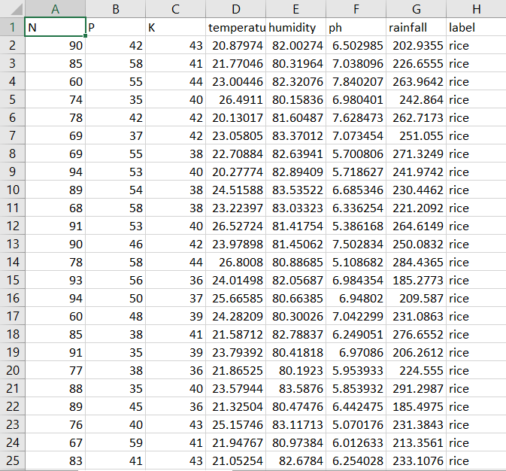

**GRAPHS PLOTTED BETWWEN FEATURE AND TARGET VARIABLES:**

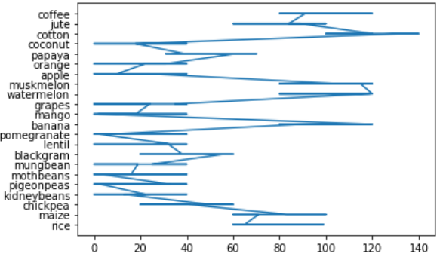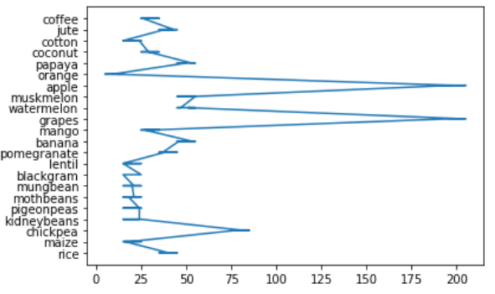

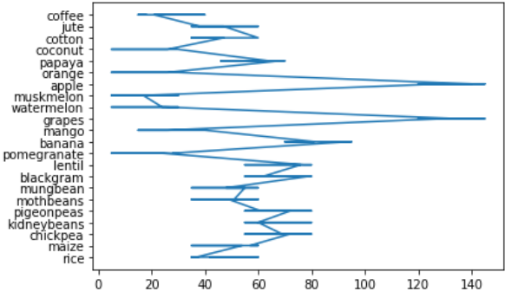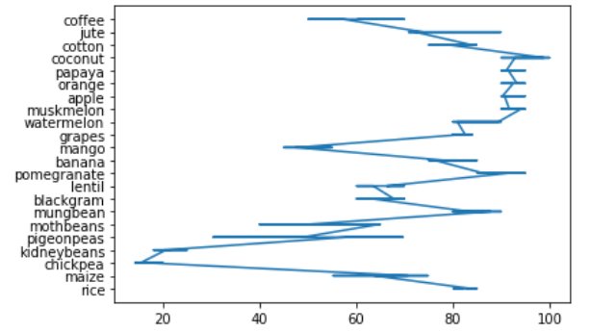

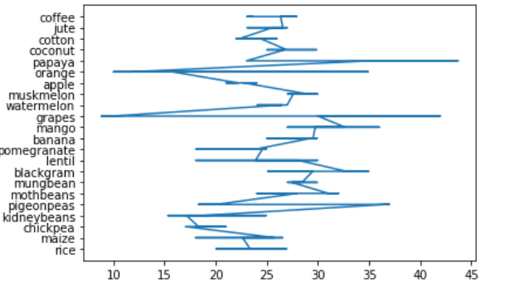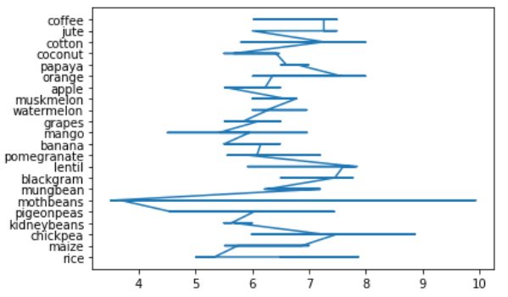

# 6. RESULTS:

**CODE**

**Dataset:**

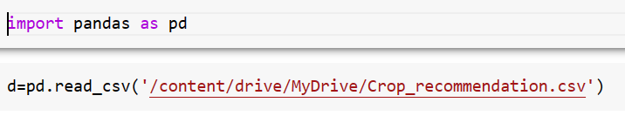

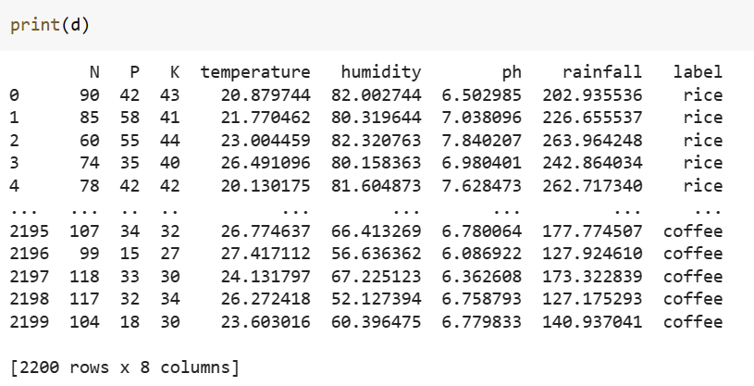

**Logistic Regression:**

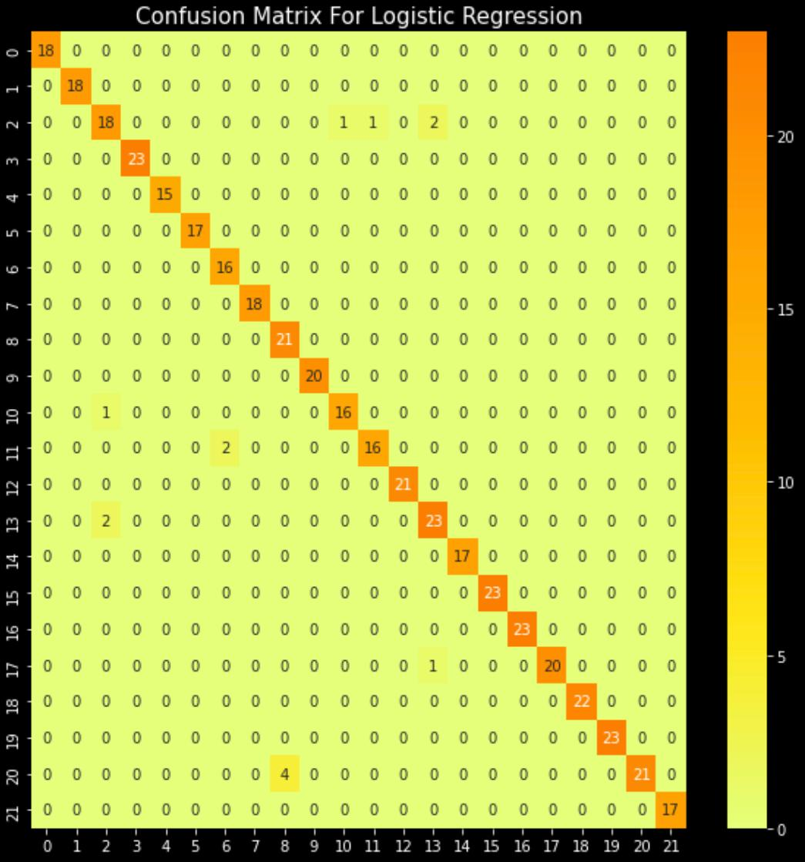

**K Nearest Neighbor:**

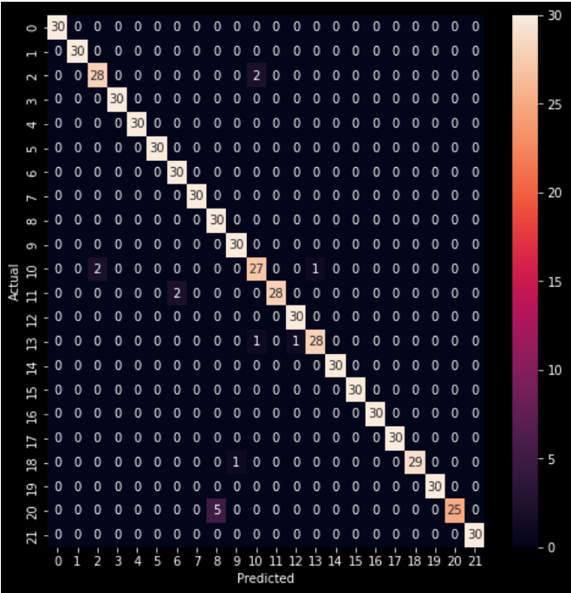

**Decision tree:**

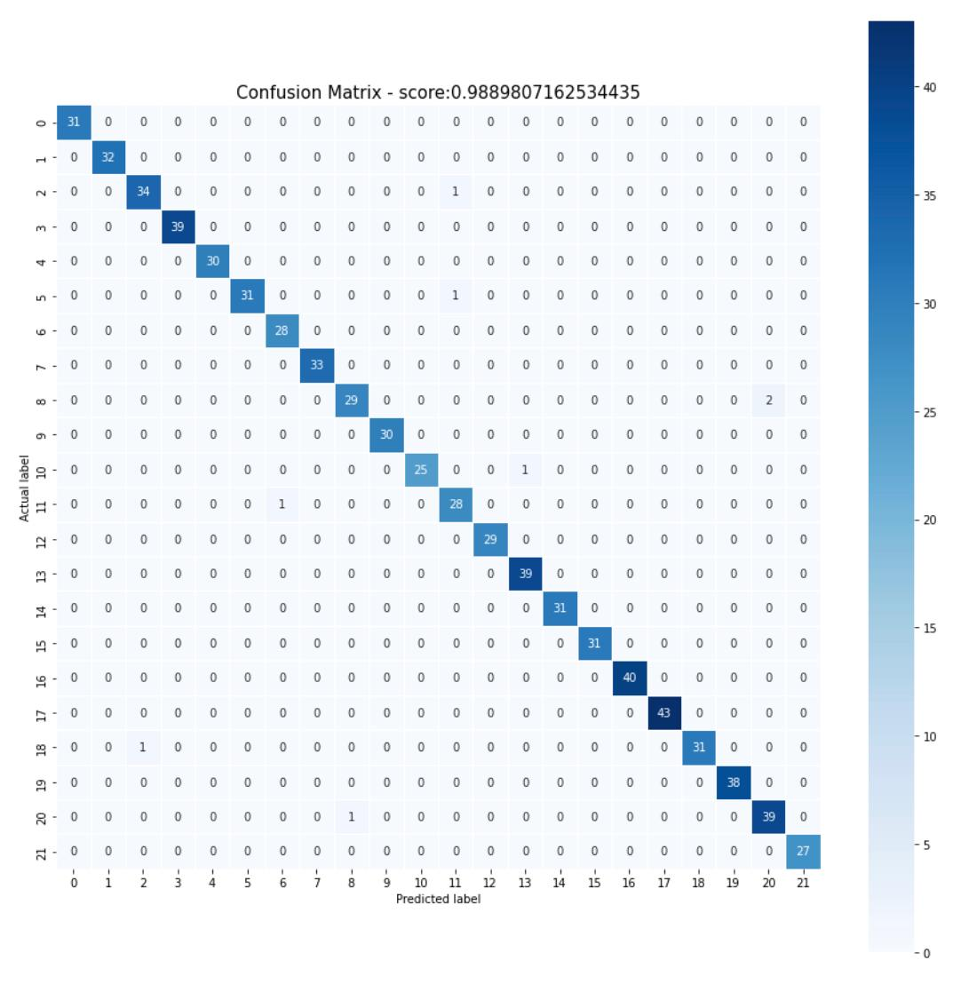

**Support Vector machine:**

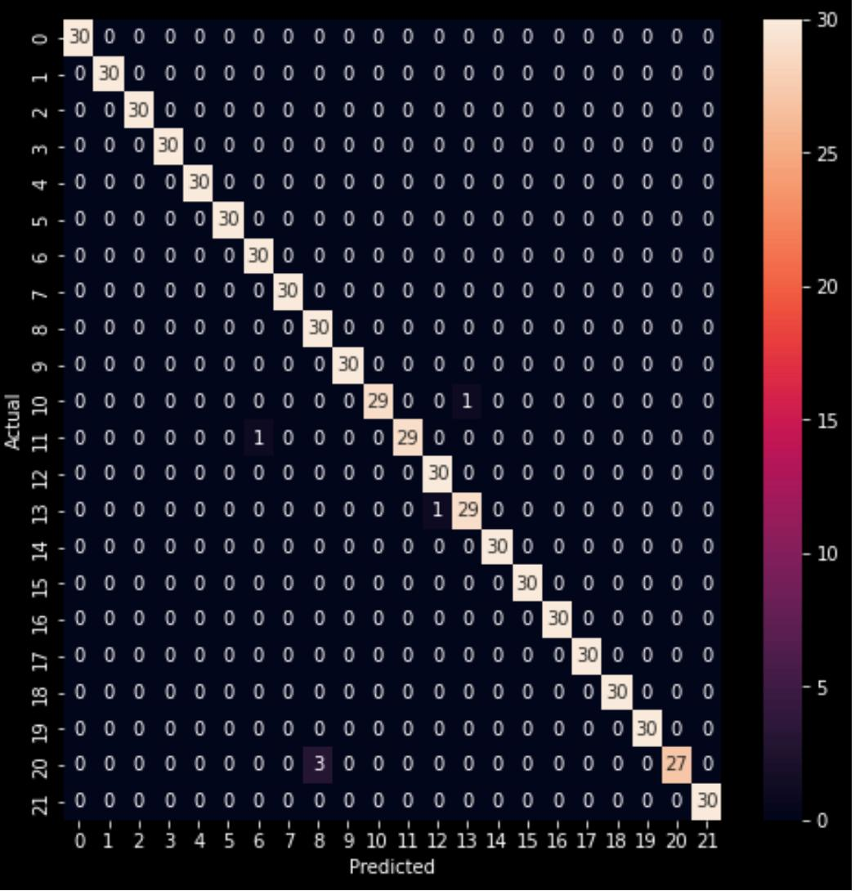

|  |  |  |
| --- | --- | --- |
| **S.NO** | **MACHINE LEARNING MODEL** | **ACCURACY** |
| 1 | Logistic regression | 0.9932 |
| **2** | K-Nearest Neighbor | 0.9327 |
| **3** | Support vector Machine | 0.9159090909090909 |
| **4** | Decision Tree | 0.9909 |

# 7. CONCLUSION:

Among worldwide, agriculture has the major responsibility for improving the economic contribution of the nation. However, still the most agricultural fields are under developed due to the lack of deployment of ecosystem control technologies. To prevent this problem, Agricultural sectors have to predict the crop from given data set using machine learning techniques. The proposed framework considers the information identifying with the yield of season, area, soil parameters and past year and recommends which are the best beneficial harvests that can be developed in the right natural condition.

**8. FUTURE SCOPE :**

The future work aimed at the analysis of the entire set of data and will be devoted to suitable strategies for improving the efficiency of the proposed algorithm. Use of such kind of approach to forecasting is not restricted to agriculture alone. We can also consider economic aspect of farmer to recommend the farmer’s most profitable crop

# 9. REFERENCES:

1. https://www.sciencedirect.com/science/article/pii/S0168192315007546
2. https://www.sciencedirect.com/science/article/pii/S0168169913001257

[3] https://doi.org/10.1109/Agro-Geoinformatics.2014.6910609

[4] https://doi.org/10.1109/JCSSE.2016.7748856

[5] https://doi.org/10.1109/ICCTIDE.2016.7725357

[6] https://www.sciencedirect.com/science/article/pii/S1319562X17300335

[7] https://iopscience.iop.org/article/10.1088/1748-9326/aae159/meta

[8] https://link.springer.com/chapter/10.1007/978-981-10-8339-6_6